EXPERIMENT NO. 06
Radiation pattern of Broadside array and Endfire array using SCILAB

EXPERIMENT NO. 06
AIM: To study and compare radiation pattern of Broadside array and Endfire array for different values of element spacing (d).

SOFTWARE USED: SCILAB
THEORY: An antenna, when individually can radiate an amount of energy, in a particular direction, resulting in better transmission, how it would be if few more elements are added it, to produce more efficient output. It is exactly this idea, which led to the invention of Antenna arrays. An antenna array is a radiating system, which consists of individual radiators and elements. Each of this radiator, while functioning has its own induction field. The elements are placed so closely that each one lies in the neighbouring one’s induction field. Therefore, the radiation pattern produced by them, would be the vector sum of the individual ones.The spacing between the elements and the length of the elements according to the wavelength are also to be kept in mind while designing these antennas. The antennas radiate individually and while in array, the radiation of all the elements sum up, to form the radiation beam, which has high gain, high directivity and better performance, with minimum losses. he basic types of arrays are − Collinear array, Broad side array, End fire array, Parasitic array, Yagi-Uda array, Log-periodic array, Turnstile array and Super-turnstile array.
The array factor (AF) for a linear array of N isotropic point sources is given by the following equation
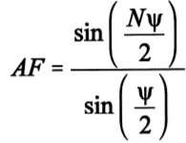
Where N represents number of sources and Ψ represents array phase function.
Broadside Array:
The broadside array is the array of antennas in which all the elements are placed parallel to each other and the direction of maximum radiation is always perpendicular to the plane consisting elements. A typical arrangement of a Broadside array is as shown in Figure 1.
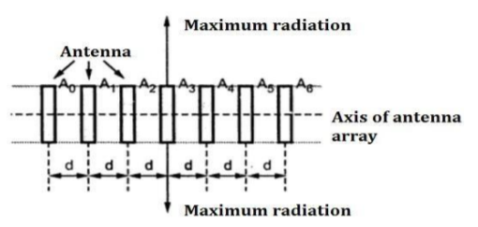
Figure 1: Typical arrangement of a Broadside array.
A broadside array consists number of identical antennas placed parallel to each other along a straight line. This straight line is perpendicular to the axis of individual antenna. It is known as axis of antenna array. Thus, each element is perpendicular to the axis of antenna array. All the individual antennas are spaced equally along the axis of antenna array. The spacing between any two elements is denoted by ′𝑑′. All the elements are fed with currents with equal magnitude and same phase. As the maximum radiation is directed in broadside direction i.e. perpendicular to the line of axis of array, the radiation pattern for the broadside array is bidirectional. Thus, broadside array can be defined as the arrangement of antennas in which maximum radiation is in the direction perpendicular to the axis of array and plane containing the elements of array.
The total phase difference of the fields at point 𝑃 from adjacent sources is given by,
𝜓 = 𝑘𝑑 cos 𝜙 +
In broadside array sources should be in phase i.e., 𝛼 = 0° and 𝜓 = 0 for maximum must be satisfied.
𝜓 = 𝑘𝑑 cos 𝜙 + 𝛼 = 0
𝑘𝑑 cos 𝜙 + 𝛼 = 0 ∵ 𝛼 = 0
cos 𝜙 = 0 ; 𝜙 _{𝑚} = 90° or 270°
The radiation pattern for a linear array of 4 isotropic point sources of equal amplitude and phase with d = λ/2 is as shown in figure 2 below.

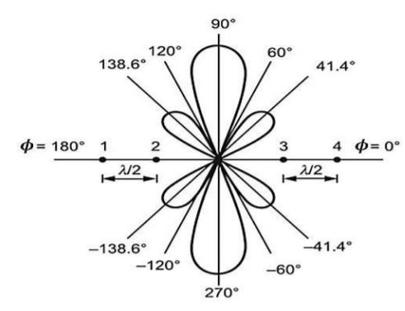
Figure 2: Radiation pattern - Broadside Array (N = 4)
Endfire Array:
The end fire array is very much similar to the broadside array from the point of view of arrangement. But the main difference is in the direction of maximum radiation. In broadside array, the direction of the maximum radiation is perpendicular to the axis of array; while in the end fire array, the direction of the maximum radiation is along the axis of array. Thus, in the end fire array number of identical antennas are spaced equally along a line. All the antennas are fed individually with currents of equal magnitudes but their phases vary progressively along the line to get entire arrangement unidirectional finally. i.e. maximum radiation along the axis of array as shown in Figure 3.
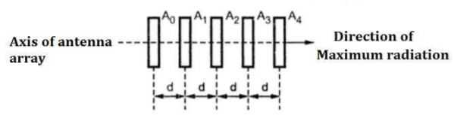

Figure 3: Typical arrangement of a Endfire array.
Thus, end fire array can be defined as an array with direction of maximum radiation coincides with the direction of the axis of array to get unidirectional radiation. The total phase difference of the fields at point 𝑃 from adjacent sources is given by, 𝜓 = 𝑘𝑑 cos 𝜙 +
In end-fire array 𝜓 = 0 and 𝜙 = 0° or 180°
𝜓 = 𝑘𝑑 cos 𝜙 + 𝛼 = 0
𝜓 = 0 and 𝜙 = 0°; 𝛼 = −𝑘𝑑
𝜓 = 0 and 𝜙 = 180°; 𝛼 = 𝑘𝑑
𝜙 _{𝑚} = 0° or 180°
The radiation pattern for a linear array of 4 isotropic point sources of equal amplitude and opposite phase with d = λ/2 is as shown in figure 4 below.
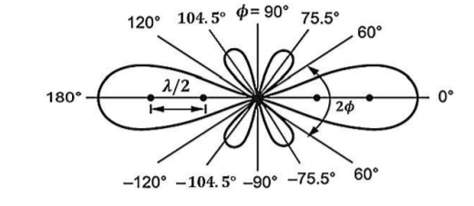
Figure 4: Radiation pattern - Endfire Array (N = 4)

Code:
- BROADSIDE ARRAY
clear;
clc;
n=10;
lambda=1;
d1=lambda/4;
k=(2*%pi)/lambda;
theta=0.0001:0.01:2*%pi;
beta=0;
psi=k*d1*cos(theta)+beta;
AF=sin(n.*psi/2)./(n*sin(psi/2));
//polarplot(theta,AF);
//d2 = lambda/4;
//psi=k*d2*cos(theta)+beta;
//AF=sin(n*psi/2)./(n*sin(psi/2));
xset('line style',3)
polarplot(theta,AF);
title("POLAR PLOT FOR ARRAY FACTOR PATTERN FOR N ELEMENT UNIFORM AMPLITUDE BROADSIDE ARRAY CASE: N=10, d=λ/4 and d=λ β=0")
h1=legend('d=λ/4','d=λ')

- ENDFIRE ARRAY
clear;
clc;
n=10;
lambda=1;
d=lambda/4;
k=(2*%pi)/lambda;
theta=0.0001:0.01:2*%pi;
beta1=-(k*d);
psi=k*d.*cos(theta)+beta1;
AF=sin(n.*psi/2)./(n.*sin(psi/2));
polarplot(theta,AF);
beta2=(k*d);
psi=k*d.*cos(theta)+beta2;
AF=sin(n.*psi/2)./(n.*sin(psi/2));
xset('line style',3)
polarplot(theta,AF);
title("POLAR PLOT FOR ARRAY FACTOR PATTERN FOR N ELEMENT UNIFORM AMPLITUDE END FIRE ARRAY CASE:N=10,d=lambda/4,beta=+-(Kd)")
h1=legend('beta=Kd','beta=-Kd')

Output:
- Broadside array
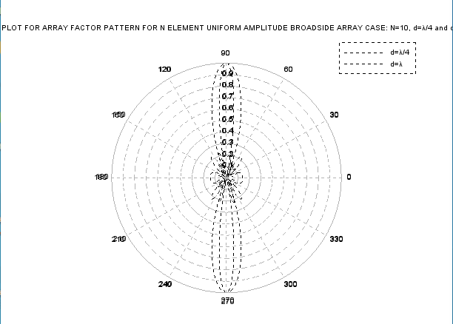

- EndFire array
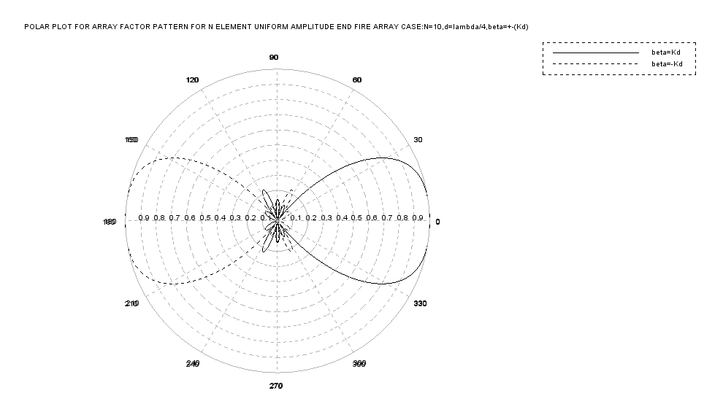

Conclusion:
Radiation pattern of Broadside array and Endfire array for different values of element spacing (d) using scilab was performed successfully. For Broadside array the radiation pattern for a linear array has equal amplitude and phase with d = λ/4. For endfire array side the radiation pattern for a linear array has equal amplitude and opposite phase with d = λ/4.

EXPERIMENT NO.07
Loop antenna using 4NEC2

EXPERIMENT NO.07
AIM: To draw radiation pattern of loop antenna using 4NEC2 software and to find VSWR, return loss and gain.
SOFTWARE REQUIRED:
4NEC2
THEORY:
An RF current carrying coil is given a single turn into a loop, can be used as an antenna called as loop antenna. The currents through this loop antenna will be in phase. The magnetic field will be perpendicular to the whole loop carrying the current. The frequency range of operation of loop antenna is around 300MHz to 3GHz. This antenna works in UHF range. A loop antenna is a coil carrying radio frequency current. It may be in any shape such as circular, rectangular, triangular, square or hexagonal according to the designer’s convenience.
Loop antennas are of two types.
- Large loop antennas
- Small loop antennas

Large loop antennas
Large loop antennas are also called as resonant antennas. They have high radiation efficiency. These antennas have length nearly equal to the intended wavelength.
L=λ
Where,
- L is the length of the antenna
- λ is the wavelength
The main parameter of this antenna is its perimeter length, which is about a wavelength and should be an enclosed loop. It is not a good idea to meander the loop so as to reduce the size, as that increases capacitive effects and results in low efficiency.

Small loop antennas
Small loop antennas are also called as magnetic loop antennas. These are less resonant. These are mostly used as receivers.
These antennas are of the size of one-tenth of the wavelength.
L=λ/10
Where,
- L is the length of the antenna
- λ is the wavelength

The features of small loop antennas are −
- A small loop antenna has low radiation resistance. If multi-turn ferrite core constructions are used, then high radiation resistance can be achieved.
- It has low radiation efficiency due to high losses.
- Its construction is simple with small size and weight.
The polarization of the loop antenna will be vertically or horizontally polarized depending upon the feed position. The vertical polarization is given at the center of the vertical side while the horizontal polarization is given at the center of the horizontal side, depending upon the shape of the loop antenna.
The small loop antenna is generally a linearly polarized one. When such a small loop antenna is mounted on top of a portable receiver, whose output is connected to a meter, it becomes a great direction finder.
The radiation pattern of these antennas will be same as that of short horizontal dipole antenna.

PROCEDURE:

1. Run the program, 4nec2.
2. Three windows should now be open on your desktop.
3. The first window, labeled “Main” gives quick access to all the components of 4nec2. It also displays certain information about your antenna, including input (series) impedance, input parallel impedance, Radiation Efficiency, Input Voltage &Current, operating frequency and wavelength in free space of the given frequency, etc. The main window can be brought up at any time by hitting F2.
4. The second window is the “Pattern” page. This page displays a 2D polar plot of the radiation pattern of your antenna. By default, this page shows the theta plane of the antenna’s radiation pattern. It can be switched to the phi (horizontal) plane by going to “Far Field” => “Horizontal Plane”. Theta and phi can be swept for the phi plane and theta plane, respectively, by using the left and right arrows on your
keyboard. This window can be brought up at any time by hitting F4.
5. The third window is the “Geometry” window. This window shows the physical representation of your antenna. It also shows where your sources are by representing them with purple circle. This window can be brought up at any time by hitting F3.
6. Not shown, is the “4nec2 Edit” window. This window can be brought up by hitting the “Edit NEC input file” button on the main window. The button looks like a hand holding a pencil while writing something in a book.
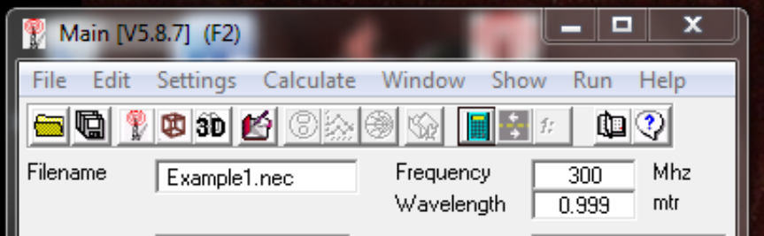
This window is used for inputting your antenna design and running your test. It will be described in
detail in the following instructions.
7. Open the “4nec2 Edit” window.
8. In the “4nec2 Edit” window, click on the Symbols Tab. This tab is used for defining variables in your system.
Click in the blank space underneath “Symbols and Equations”

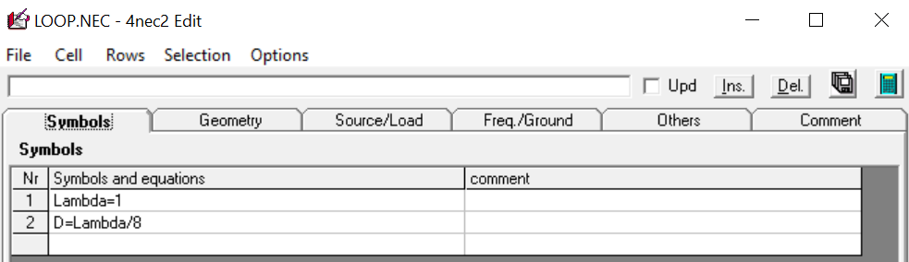

9. Click on the “Geometry” tab.
The “Geometry” tab in the “4nec2 Edit” window is where you will define your antenna’s structure. In any nec2 program, such as 4nec2, you define your antenna by first building a series of lines. Each line will be assigned a reference number, a number of segments, and a radius.
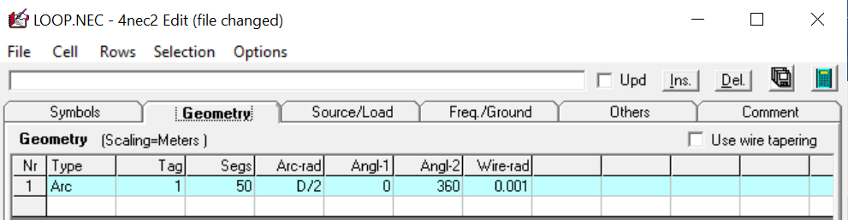

10. Click the “Source/Load” tab. In this tab you will define one of the segments on your wire to be a source for the antenna.
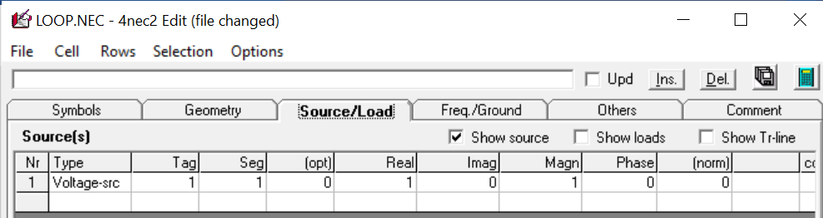
11. Click the “Freq./Ground” tab. This tab allows us to define our operating frequency. 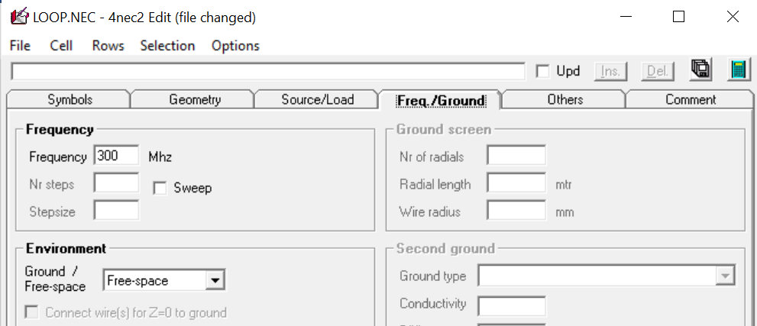12. Click the “Run NEC” button in the upper right-hand corner of the “4nec2 Edit” window. This is the button that looks like a calculator.
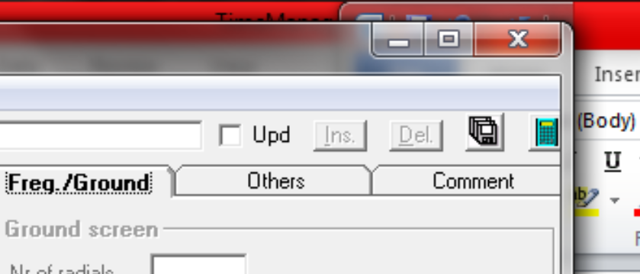
13. Select far‐field in the window that pops up. Then click the “Generate” button in the bottom left.
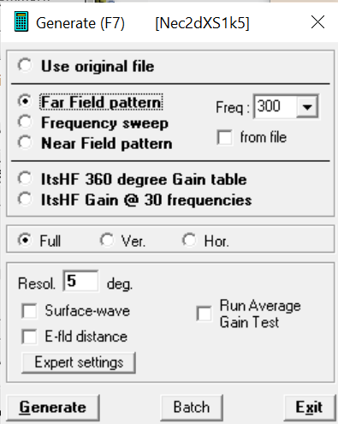
14. Press F4 to bring up the radiation pattern display on the polar plot. On this page you can see a 2D representation of the radiation pattern of your antenna. To switch between a vertical and horizontal plane view, select “Far field” => “Horizontal plane” or press the “spacebar”.
To change the angle of viewing, use the “up”/” down” arrows on your keyboard.
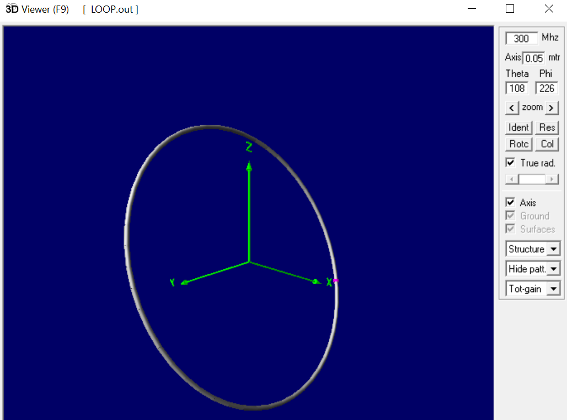

Observation:

Small loop antenna:

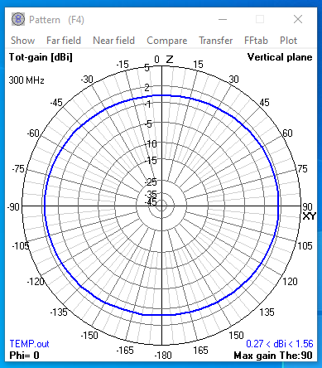

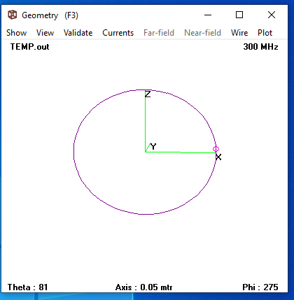

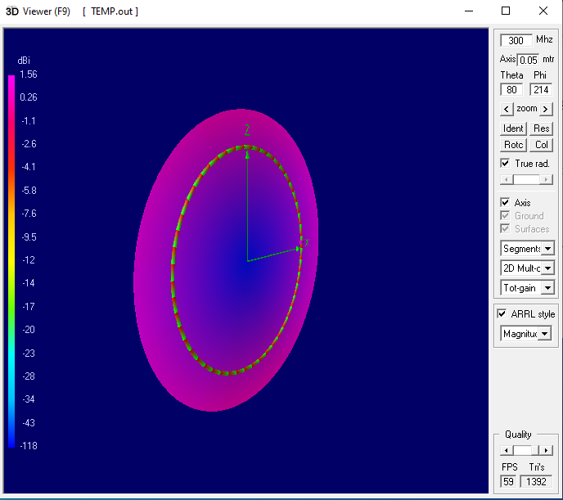
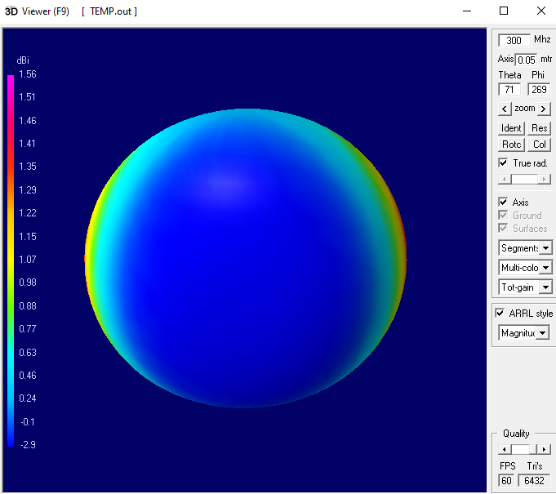

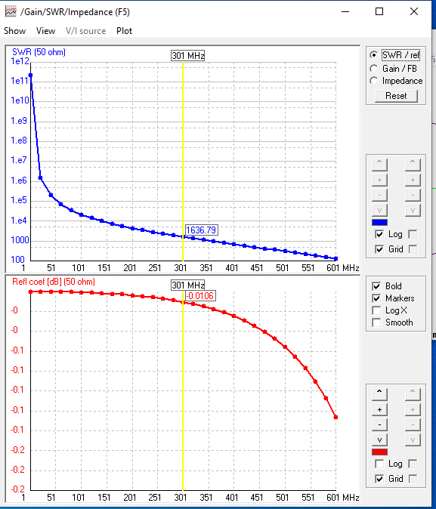

Large Loop Antenna:
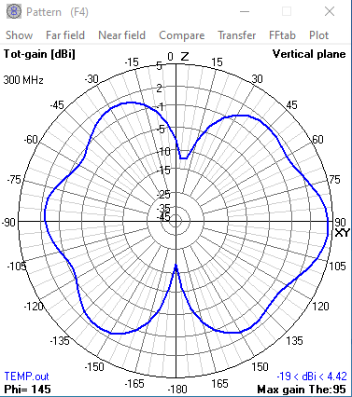
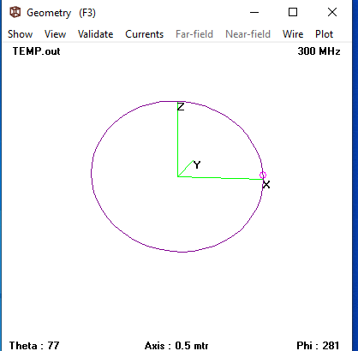
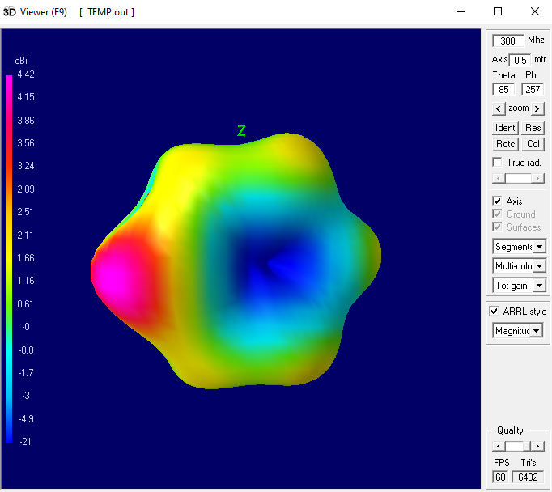
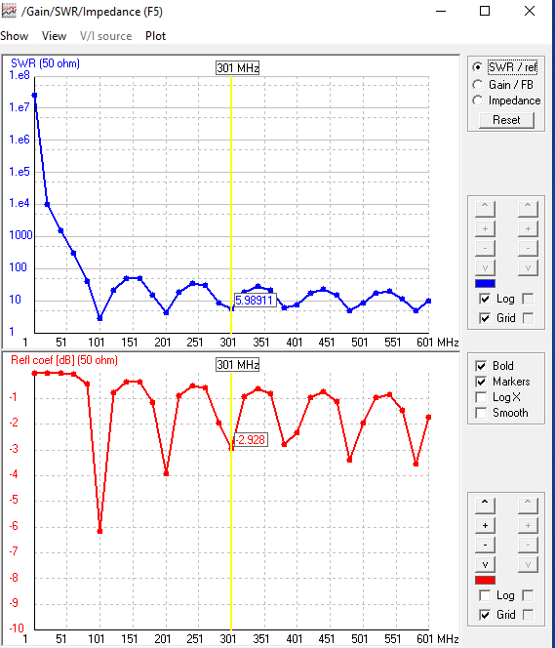

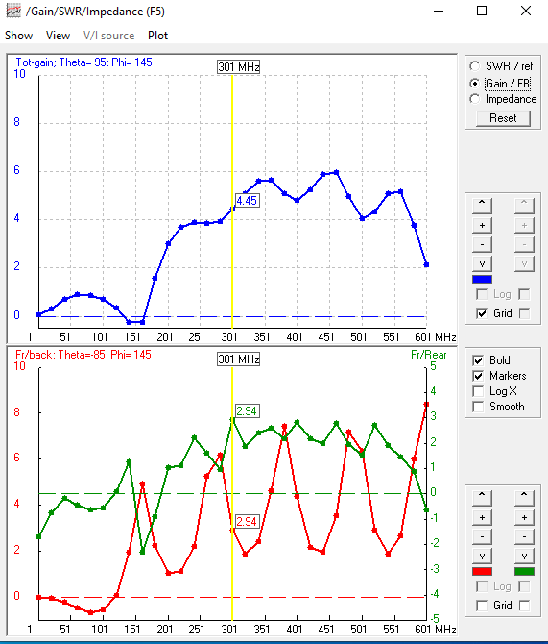

Conclusion:
The radiation pattern of loop antenna using 4NEC2 software and to find VSWR, return loss and gain was performed successfully. Small lopp antenna are less resonant compared to large loop antenna. The max gain for small loop is 90 and for large loop is 95. Radiation pattern for small antenna is isotropic and for large antenna is directional.

EXPERIMENT NO.08
Monopole antenna using 4NEC2

EXPERIMENT NO.08
AIM: To draw radiation pattern of monopole antenna using 4NEC2 software and to find VSWR, return loss and gain.
SOFTWARE REQUIRED:
4NEC2
THEORY:
The driving signal from the transmitter is applied, or for receiving antennas the output signal to the receiver is taken, between the lower end of the monopole and the ground plane. One side of the antenna feedline is attached to the lower end of the monopole, and the other side is attached to the ground plane, which is often the Earth.
A monopole can be visualized (right) as being formed by replacing the bottom half of a vertical dipole antenna (c) with a conducting plane (ground plane) at right-angles to the remaining half. If the ground plane is large enough, the radio waves from the remaining upper half of the dipole (a) reflected from the ground plane will seem to come from an image antenna (b) forming the missing half of the dipole, which adds to the direct radiation to form a dipole radiation pattern. So the pattern of a monopole with a perfectly conducting, infinite ground plane is identical to the top half of a dipole pattern, with its maximum radiation in the horizontal direction, perpendicular to the antenna. Because it radiates only into the space above the ground plane, or half the space of a dipole antenna, a monopole antenna will have a gain of twice (3 dB greater than) the gain of a similar dipole antenna, and a radiation resistance half that of a dipole.
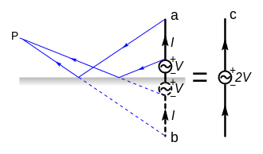
PROCEDURE:

1. Run the program, 4nec2.
2. Three windows should now be open on your desktop.
3. The first window, labeled “Main” gives quick access to all the components of 4nec2. It also displays certain information about your antenna, including input (series) impedance, input parallel impedance, Radiation Efficiency, Input Voltage &Current, operating frequency and wavelength in free space of the given frequency, etc. The main window can be brought up at any time by hitting F2.
4. The second window is the “Pattern” page. This page displays a 2D polar plot of the radiation pattern of your antenna. By default, this page shows the theta plane of the antenna’s radiation pattern. It can be switched to the phi (horizontal) plane by going to “Far Field” => “Horizontal Plane”. Theta and phi can be swept for the phi plane and theta plane, respectively, by using the left and right arrows on your
keyboard. This window can be brought up at any time by hitting F4.
5. The third window is the “Geometry” window. This window shows the physical representation of your antenna. It also shows where your sources are by representing them with purple circle. This window can be brought up at any time by hitting F3.
6. Not shown, is the “4nec2 Edit” window. This window can be brought up by hitting the “Edit NEC input file” button on the main window. The button looks like a hand holding a pencil while writing something in a book.
This window is used for inputting your antenna design and running your test. It will be described in
detail in the following instructions.
7. Open the “4nec2 Edit” window.
8. In the “4nec2 Edit” window, click on the Symbols Tab. This tab is used for defining variables in your system.
Click in the blank space underneath “Symbols and Equations”
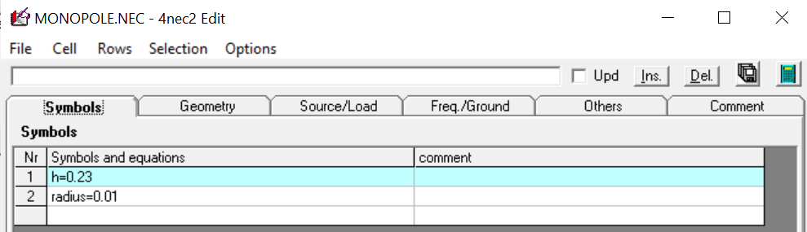
9. Click on the “Geometry” tab.
The “Geometry” tab in the “4nec2 Edit” window is where you will define your antenna’s structure. In any nec2 program, such as 4nec2, you define your antenna by first building a series of lines. Each line will be assigned a reference number, a number of segments, and a radius.
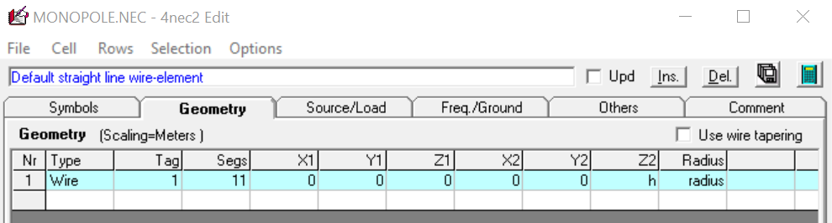

10. Click the “Source/Load” tab. In this tab you will define one of the segments on your wire to be a source for the antenna.
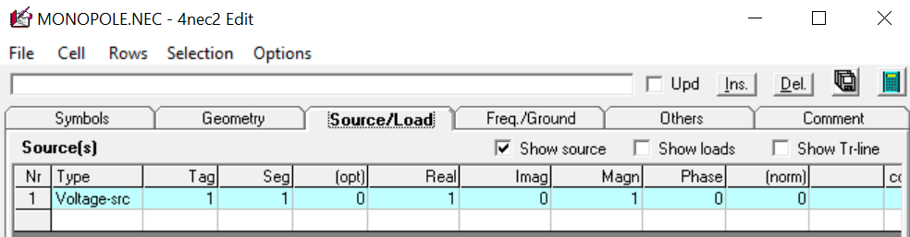
11. Click the “Freq./Ground” tab. This tab allows us to define our operating frequency.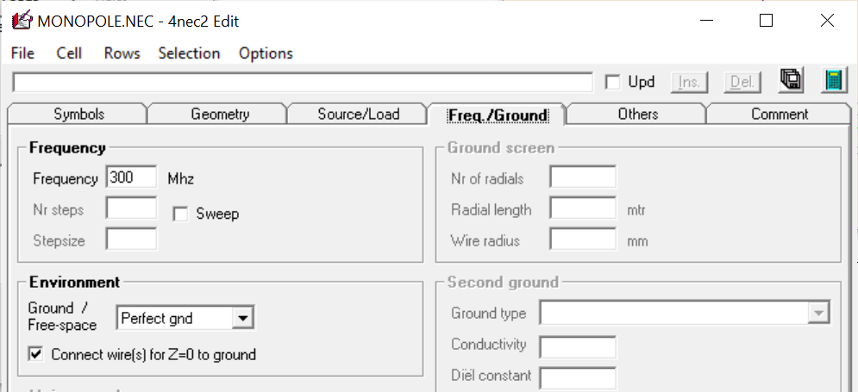12. Click the “Run NEC” button in the upper right-hand corner of the “4nec2 Edit” window. This is the button that looks like a calculator.
13. Select far‐field in the window that pops up. Then click the “Generate” button in the bottom left.
14. Press F4 to bring up the radiation pattern display on the polar plot. On this page you can see a 2D representation of the radiation pattern of your antenna. To switch between a vertical and horizontal plane view, select “Far field” => “Horizontal plane” or press the “spacebar”.
To change the angle of viewing, use the “up”/” down” arrows on your keyboard.
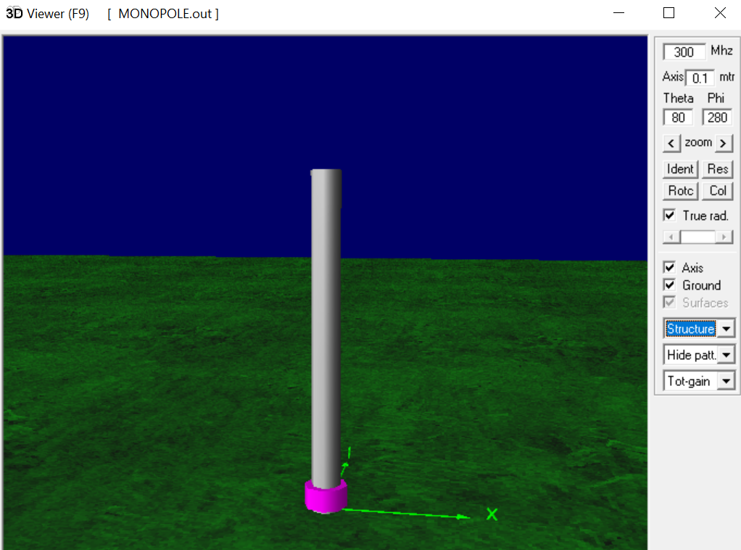

Observation:
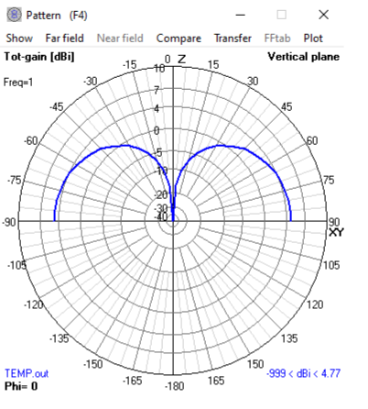
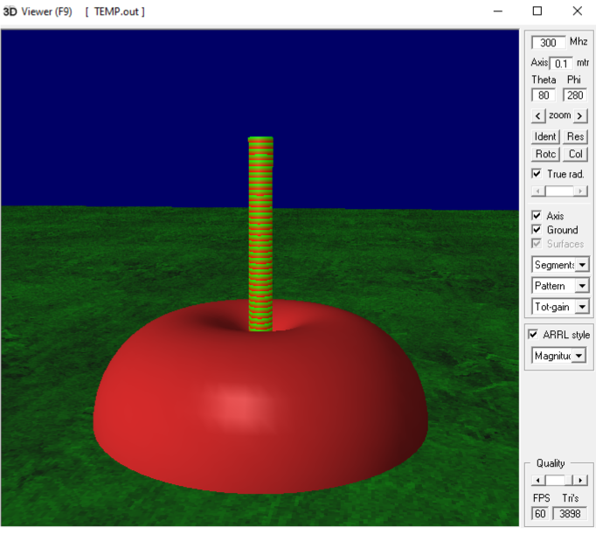
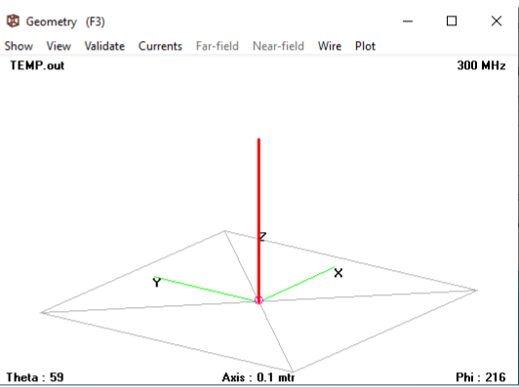
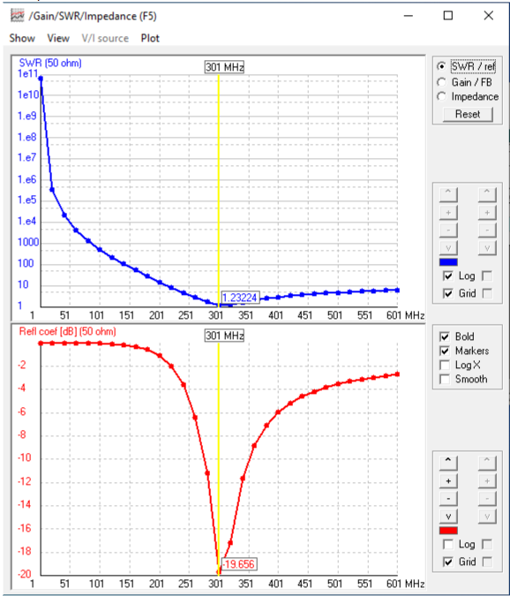
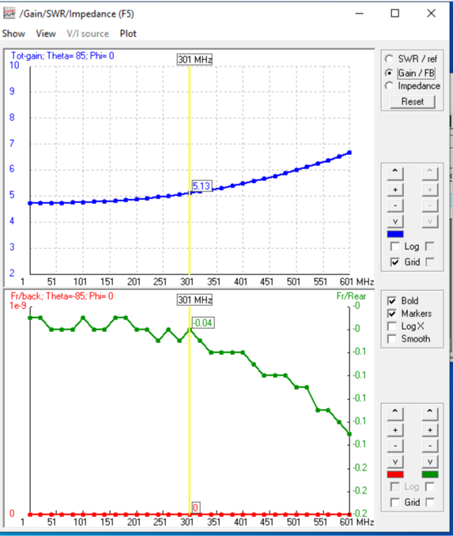

Conclusion:
The radiation pattern of monopole antenna using 4NEC2 software and to find VSWR, return loss and gain was performed successfully. The max gain is 85. The radiation pattern for monopole is omni-directional. a radiation resistance half that of a dipole.

